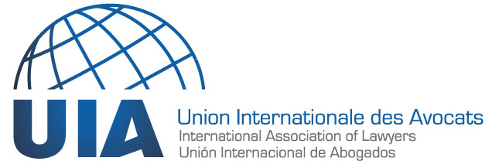

Sheikh Khalifa Bin Zayed Al Nahyan
President of the United Arab Emirates,
Ministry of Presidential Affairs,
Corniche Road, PO Box 280,
Abu Dhabi
UNITED ARAB EMIRATES
Email: ihtimam@mopa.ae
Fax: +971 2 622 2228

Re: Request for the immediate and unconditional release of our colleague Mohammed al-Roken

Your Highness,

As a member of the Union Internationale des Avocats (UIA - International Association of Lawyers), an organization active in support of threatened lawyers across the world, I have the honour to draw your attention to our colleague Mohammed al-Roken, who was arrested on July 17, 2012 and has since been held in the Al Rezin prison in Abu Dhabi.

Mohammed al-Roken was sentenced on July 2, 2013 to ten years in prison and banned from practicing law. He was convicted of defending the freedom of conscience in his country, including in his organization, which was accused of tarnishing the reputation and institutions of the United Arab Emirates.

Five years after this sentence was rendered in a judicial proceeding roundly criticized for its lack of fairness and due process, we remain deeply concerned about the fate of our colleague Mohammed al-Roken.

A lawyer and university professor, as well as UIA Vice President of the UAE National Committee from 2001 to 2006, Mohammed al-Roken has devoted many years of his life to working for the defence of human rights. His commitment to human rights was internationally recognized when he was awarded the 2017 Ludovic Trarieux Prize.

Unfortunately, as a result of this commitment to justice and human rights, Mohammed al-Roken was constantly subjected to harassment, intimidation and surveillance. At his trial, he was denied the fundamental rights to due process and a fair trial, access to evidence and the right to be effectively represented by counsel. These violations are contrary to international law and norms.

We, the lawyers and citizens of the world engaged in the defence and protection of threatened and persecuted lawyers across the globe, urge Your Highness to do everything in your power to protect the fundamental rights of those who themselves defend and promote human rights. To that end, we specifically ask that you ensure the immediate release of Mohammed al-Roken.

Yours sincerely,

ADDRESSES:

H.H. Sheikh Khalifa bin Zayed al-Nahyan,
President of the United Arab Emirates,
Ministry of Presidential Affairs,
Corniche Road,
Abu Dhabi PO Box 280,
UNITED ARAB EMIRATES
Fax: +971 2 622 2228
Email: ihtimam@mopa.ae

Vice President and Prime Minister
H.H. Sheikh Mohammed Bin Rashid al-Maktoum
Prime Minister’s Office
PO Box: 212000
Dubai,
UNITED ARAB EMIRATES
Fax: +971 4 330 4044
Email: info@primeminister.ae
Twitter: @HHShkMohd

Minister of Interior
H.H. Sheikh Saif bin Zayed al-Nahyan
Ministry of the Interior
Zayer Sport City,
Arab Gulf Street,
Near to Sheikh Zayed Mosque
PO Box: 398
Abu Dhabi
UNITED ARAB EMIRATES
Fax: +971 2 402 2762 / +971 2 441 5780
Twitter: @SaifBZayed
Email: (via website): https://www.moi.gov.ae/en/contactus/contactusform.aspx

COPIES TO:

Crown Prince of Abu Dhabi and Deputy Supreme Commander of the UAE Armed Forces
H.H. Sheikh Mohammed Bin Zayed al-Nahyan
Crown Prince Court
King Abdulaziz al-Saud Street
PO Box: 124 Abu Dhabi
UNITED ARAB EMIRATES

H.E. Obaid Salem Saeed Nasser AL ZAABI
Ambassador/Representative of the United Arab Emirates to the United Nations and Other International Organizations in Geneva
56, rue de Moillebeau
1209 Geneva
SWITZERLAND
Fax: + 41 22 734 55 62
Email: genevaUNPRM@mofa.gov.ae

Embassies - USA, Delegation of the European Union, France, Belgium, Spain, Italy, Mexico, Senegal, etc.

